Maxflow-Mincut Theorem

The **net flow across** a cut (A, B) is the sum of the flows of its edges from A to B minus the sum of the flows on its edges from B to A.

**Flow-value lemma:** Let f be any flow and let (A, B) be any cut. Then, the net flow across (A, B) equals the value of f.

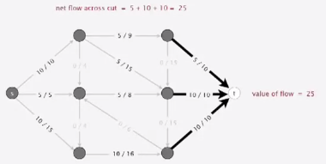

More complicated example:

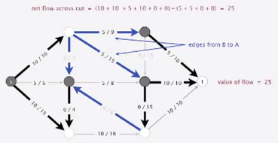

Proof: by induction on the size of B.

* Base case: B = { t }.
* Induction step: remains true by local equilibrium when moving any vertex from A to B

Corollary: outflow from s == inflow to t == value of flow.

Relationship between flows and cuts

Weak duality: Let f be any flow and let (A, B) be any cut. Then, the value of the flow <= the capacity of the cut.

Proof: Value of the flow f == (flow value lemma) net flow across cut (A, B) <= (flow bounded by capacity) capacity of cut (A, B)

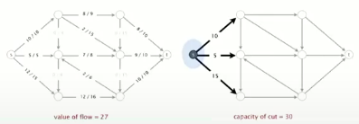

Augmenting path theorem: a flow f is a maxflow iff no augmenting paths

Maxflow-mincut theorem: value of the maxflow == capacity of mincut

Proof: The following three conditions are equivalent for any flow f:

1. There exists a cut whose capacity equals the value of the flow f
2. F is a maxflow
3. There is no augmenting path with respect to f

[i -> ii]

* Suppose that [A, B] is a cut with capacity equal to the value of f
* Then, the value of any flow f <= (weak duality) capacity of (A, B) = (by assumption) value of f

[ii -> iii] *we prove contrapositive [~iii -> ~ii]*

* Suppose that there is an augmenting path with respect to f
* Can improve flow f by sending flow along this path
* Thus, f is not a maxflow

[iii -> i]

Suppose that there is no augmenting path with respect to f

* Let (A, B) be a cut where A is the set of vertices connected to s by an undirected path with no full forward or empty backward edges
* By definition, s is in A; since no augmenting path, t is in B
* Capacity of cut == net flow across cut ( <- forward edges full; backward edges empty)

== value of flow f ( <- flow-value lemma)

To compute mincut (A, B) from maxflow f:

* By augmenting path theorem, no augmenting paths with respect to f
* Compute A = set of vertices connected to s by an undirected path with no full forward or empty backward edges

